**UNIT II CREATING THE CULTURE OF LEARNING AND KNOWLEDGE SHARING 8**

0rganization and Knowledge Management - Building the Learning Organization. Knowledge Markets: Cooperation among Distributed Technical Specialists – Tacit Knowledge and Quality Assurance.

**ORGANIZATION AND KNOWLEDGE MANAGEMENT:**

**MANAGEMENT CHALLENGES:**

* KNOWLEDGE MANAGEMENT IN THE ORGANIZATION
* INFORMATION & KNOWLEDGE WORK SYSTEMS
* ARTIFICIAL INTELLIGENCE
* OTHER INTELLIGENT TECHNIQUES.

**KNOWLEDGE MANAGEMENT IN THE ORGANIZATION:**

* Office Automation Systems (OAS)
* Knowledge Work Systems (KWS)
* Group Collaboration Systems (GCS)
* Artificial Intelligence Applications (AI)

**ORGANIZATIONAL KNOWLEDGE:**

Organizational and collective knowledge include:

* rules
* procedures,
* strategies,
* activities,
* technologies,
* conditions,
* paradigms,
* frames of references;

**LEARNING ORGANIZATION:**

* LO is not about "more training", it involves the development of higher levels of knowledge and skill.
* Management in learning organizations focuses more on how individuals think, what they truly want, and how they interact and learn with one another.
* Learning provides the opportunity to create and recreate, change one's external perception of the world and relationship, and extends individual ability to be creative.

**BUILDING THE LEARNING ORGANIZATION:**

Learning organizations are skilled at five main activities: systematic problem solving, experimentation with new approaches, learning from their own experience and past history, learning from the experiences and best practices of others, and transferring knowledge quickly and efficiently throughout the organization. Each is accompanied by a distinctive mind-set, tool kit, and pattern of behavior. Many companies practice these activities to some degree. But few are consistently successful because they rely largely on happenstance and isolated examples. By creating systems and processes that support these activities and integrate them into the fabric of daily operations, companies can manage their learning more effectively.

**1. Systematic problem solving**

This first activity rests heavily on the philosophy and methods of the quality movement. Its underlying ideas, now widely accepted, include:

Relying on the scientific method, rather than guesswork, for diagnosing problems (what Deming calls the “Plan, Do, Check, Act” cycle, and others refer to as “hypothesis-generating, hypothesis-testing” techniques).

Insisting on data, rather than assumptions, as background for decision making (what quality practitioners call “fact-based management”).

Using simple statistical tools (histograms, Pareto charts, correlations, cause-and-effect diagrams) to organize data and draw inferences.

**2. Experimentation**

This activity involves the systematic searching for and testing of new knowledge. Using the scientific method is essential, and there are obvious parallels to systematic problem solving. But unlike problem solving, experimentation is usually motivated by opportunity and expanding horizons, not by current difficulties. It takes two main forms: ongoing programs and one-of-a-kind demonstration projects.

**3. Learning from past experience**

Companies must review their successes and failures, assess them systematically, and record the lessons in a form that employees find open and accessible. One expert has called this process the “Santayana Review,” citing the famous philosopher George Santayana, who coined the phrase “Those who cannot remember the past are condemned to repeat it.” Unfortunately, too many managers today are indifferent, even hostile, to the past, and by failing to reflect on it, they let valuable knowledge escape.

**4. Learning from others**

Of course, not all learning comes from reflection and self-analysis. Sometimes the most powerful insights come from looking outside one’s immediate environment to gain a new perspective. Enlightened managers know that even companies in completely different businesses can be fertile sources of ideas and catalysts for creative thinking. At these organizations, enthusiastic borrowing is replacing the “not invented here” syndrome. Milliken calls the process SIS, for “Steal Ideas Shamelessly”; the broader term for it is benchmarking.

**5. Transferring knowledge**

For learning to be more than a local affair, knowledge must spread quickly and efficiently throughout the organization. Ideas carry maximum impact when they are shared broadly rather than held in a few hands. A variety of mechanisms spur this process, including written, oral, and visual reports, site visits and tours, personnel rotation programs, education and training programs, and standardization programs. Each has distinctive strengths and weaknesses.

Reports and tours are by far the most popular mediums. Reports serve many purposes: they summarize findings, provide checklists of dos and don’ts, and describe important processes and events. They cover a multitude of topics, from benchmarking studies to accounting conventions to newly discovered marketing techniques.

**COLLECTIVE LEARNING:**

Collective learning requires skills for sharing information and knowledge, particularly implicit knowledge, assumptions and beliefs that are traditionally "beneath the surface".

Subsequently, the main skills are:

* communication (across organizational boundaries)
* listening and observing
* mentoring and supporting colleagues
* holistic perspective (the organization as a whole).

**CHARACTERISTICS OF LEARNING ORGANIZATION:**

* Learning Culture
* Management Processes
* Tools and Techniques
* Skills and Motivation
* Free exchange and flow of information
* Commitment to learning, personal development
* Valuing people
* Fostering a climate of openness and trust
* Learning from experience.

**WHAT IS ORGANIZATIONAL CULTURE?**

The social elements of knowledge that have been underlined in previous sections are at least partially dependent on organizational and community culture. Organizational culture determines values and beliefs which are an integral part of what one chooses to see and absorb (Davenport & Prusak 2000). It includes a shared perception of reality, regarding how things are and how things should be. Furthermore, community and group culture determine the willingness and conditions for knowledge sharing with other members of the organization. Knowledge, and knowledge sharing, are thus inseparable from organisational culture.

**KNOWLEDGE SHARING:**

One major influence to a culture's knowledge sharing willingness is the issue of reciprocity (Davenport & Prusak 2000). This refers to the individual's need to perceive a current or future return on the knowledge he chooses to share. This could be in the form of direct compensation of some kind; it could be something intangible like enhancing the individual's reputation; but it can also be the knowledge that the favor will be returned the next time he requires assistance.

Finally, internal competition is yet another aspect of organizational culture that may interfere with the knowledge sharing and knowledge creation process.

**KNOWLEDGE MARKETS:**

**Orders of knowledge:**

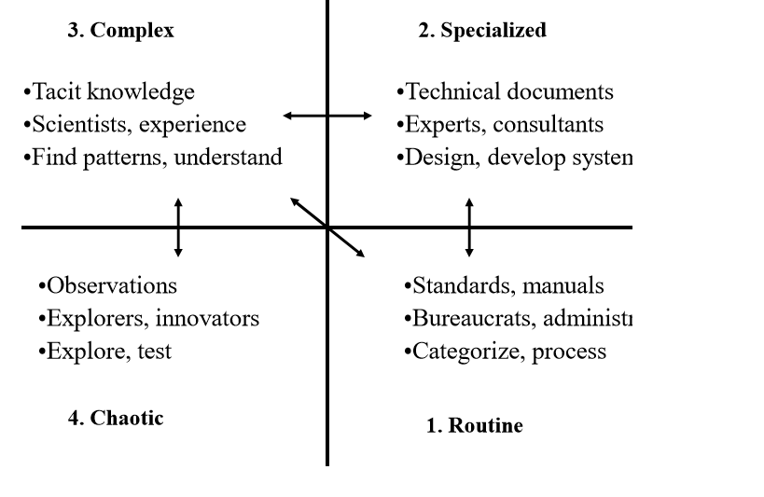

**KNOWLEDGE SERVICES STAGES:**

1. Generate (start Knowledge Services value chain)

2. Transform (goods & services increase utility, value)

3. Manage (permit transfer)

4. Use Internally (accomplish organizational objectives)

5. Transfer (enable external use)

6. Enhance (increase availability, utility, value)

7. Use Professionally (sector derives benefits)

8. Use Personally (individuals derive benefits)

9. Evaluate (organizational mandate, resources.

**KNOWLEDGE MARKETS**

There are four types of knowledge services:

* Content
* products
* services
* solutions.

**Content:** “Embedded value, in the form of the message or signal contained within elements of the content value chain.”

**Products:** “Tangible, storable commodity or merchandise, with embedded value, derived from content.”

**Services:** “Intangible, non-storable work, function, or process, with embedded value, derived from content.”

**Solutions:** “Successful use of content, products, or services to embed and extract value by accomplishing organizational tasks.”

A Knowledge-services value chain represents the flow of goods and services through sequential stages, in which value is embedded, advanced, or extracted.

A knowledge market consists of a group of cyclic, interrelated knowledge services value chains.

A knowledge market model is a useful approach for measuring and managing knowledge services.

**COOPERATION AMONG DISTRIBUTED TECHNICAL SPECIALISTS:**

Organizational decentralization often leads to the distribution (or dispersion) of competence. This, in turn, encourages managerial interest in techniques for sharing important job-related knowledge among (potentially dispersed) organizational members. A second factor that encourages sharing of knowledge among organizational members reflects an interest in better using the knowledge that their workers have accumulated.

These forces, coupled with the increasing power and flexibility of information technologies, help give rise to the ‘knowledge management’ movement. For us, knowledge management means an organized and planned approach to gathering, storing, and distributing knowledge within an organization (i.e., Davenport, 1997). One contemporary approach to managing knowledge encourages diffusion of existing expertise through naturally occurring “knowledge markets”(Davenport and Prusak, 1998; Ernst & Young CBI, 1997).

Knowledge markets draw their participants from groups connected via what some call radial personal networks (Rogers & Rogers, 1976); communities of practice (Orr, 1990; Seeley-Brown & Duguid, 1991) or communities of interaction (Nonaka and Takeuchi, 1995). In this paper, we use the term “informal social networks”as a broad descriptor thatencompasses these concepts.

Sharing knowledge through informal social networks allows members to reap the benefits from that learned by the most expert. Furthermore, knowledge transfer via both formal and informal social networks take advantage of the richness embedded in the social realm. The knowledge market approach however, assumes that no “trade barriers” exist, and that knowledge flows relatively freely through the marketplace.

One example of organizational decentralization is the movement to distributed computing, exemplified by clientserver systems. This distribution of computing leads to impacts that extend beyond changes to the technological infrastructure (Kling 1980,1982,1987; Sawyer and Southwick, 1996). Distributed computing environments place more computer power in the hands of the end-user. This, in combination with commensurate end-user computing sophistication, demands increased technical support. As organizations move to distribute their computing into discrete business units, they may also move computer support personnel, referred to in this paper as distributed technical support staff (DTS), to these units.

**KNOWLEDGE MANAGEMENT, EXCHANGE THEORY AND WORK CULTURE:**

Knowledge markets are implicitly grounded on assumptions that are central to social exchange theory (Homans, 1950). And, these knowledge markets arise from within the cultural context of the members of that market – in this case the DTS’s work culture. The following sub-sections provide a brief overview of knowledge management, the underlying precepts of social exchange theory, and Schein’s (1997) model of work cultures in organizations. This model provides a framework forour data analysis and illuminates theunderlying cultural assumptions which guide behavior in the knowledge market.

**TACIT KNOWLEDGE:**

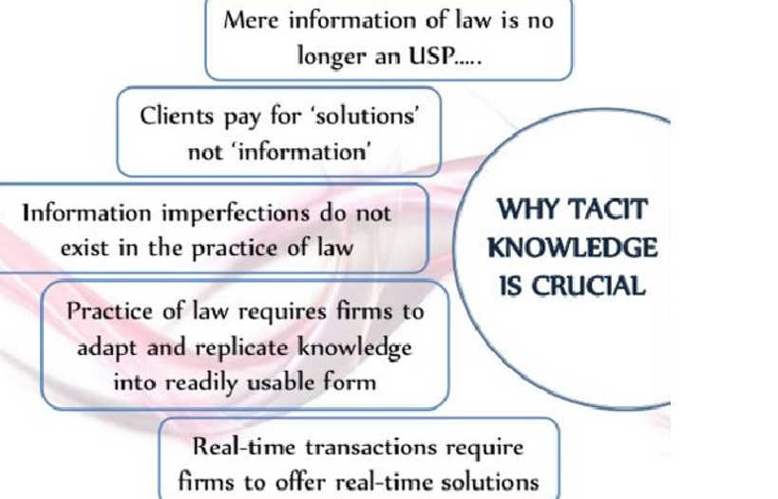

To begin to capture tacit knowledge you can channel informal discussions into a collaborative workspaces.

Collaboration means working together to fulfil a shared,collective and bounded goal.

The Gantt Chart

The kanban chart

The To –Do list

The Social Network.

**EXAMPLES OF TACIT KNOWLEDGE:**

* + Riding a bike.
  + Steering a canoe
  + Cooking a dish without a recipe
  + French braiding hair

**APPLICATIONS OF TACIT KNOWLEDGE:**

May be able to predict future success of an individual’s academic performance

May be a better predictor of career success than general intelligence

Tacit knowledge increases with job experience.

**QUALITY ASSURANCE:**